7/1/2020

**Quality analysis of https://www.premiernet.ie/**

SDA Final Project

Lina Mikutė

SDA

Table of Contents

1. Introduction 3

2. Testing section 3

3. Testing checklists 5

3.1. Checklist for Home page, Header and Footer 5

3.2. Checklist for Packages page 7

3.3. Checklist for Jet (Wireless Fibre) page 8

3.4. Checklist for Our Coverage page 10

3.5. Checklist for Support page 12

3.6. Checklist for Contact Us page 13

4. Detailed test cases 15

5. Founded issues/bugs 19

6. Improvements 25

7. Test Design Techniques 26

8. Reflection 26

1. Introduction

This is a Final project as part of Tester course program in Software Development Academy (SDA). It was chosen to test the website of Premier Broadband company: <https://www.premiernet.ie/>. The company provides wireless Internet services across rural Ireland. It is based in South East Ireland.

# Testing section

Selected website consists of 6 pages: Home, Packages, Jet (Wireless Fibre), Our Coverage, Support and Contact us. All of these pages were tested.

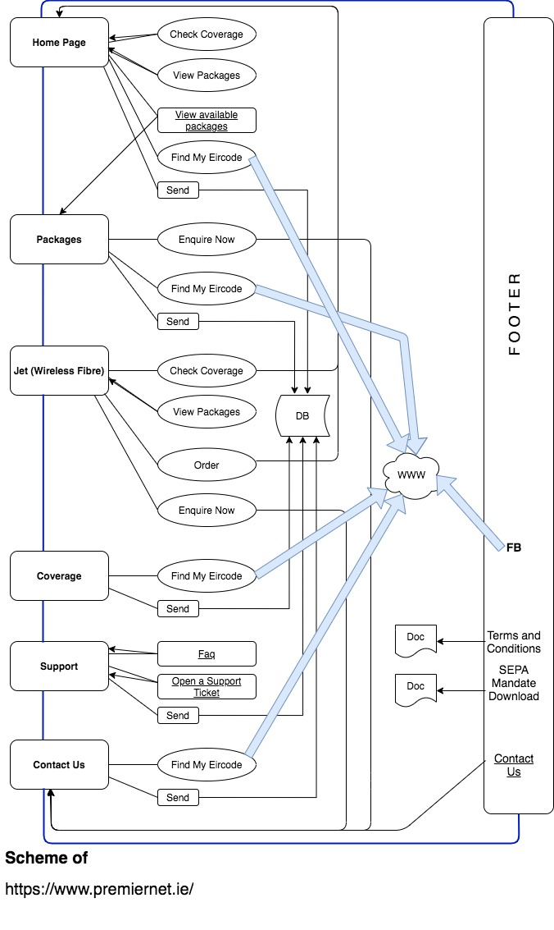

# Testing checklists

There are 6 checklists provided at this section. Each one is for separate website page. Each checklist (except checklist for Support page) contains checking points, result (pass or fail), some remarks what was wrong, and Bug number.

Bug numbers come from Bug Keys at Backlog where all bugs were registered (<https://ichigiku.backlog.com/board/SDAPROJEKTAS?category=47511)>. In order to save space only numbers of Bug Keys are provided at the tables. Each Bug Key in Backlog starts with “SDAPROJEKTAS-“.

## Checklist for Home page, Header and Footer

|  |  |  |  |  |
| --- | --- | --- | --- | --- |
|  | **Checklist for Home page, Header and Footer https://www.premiernet.ie/** | **Pass/ Fail** | **Remarks** | **Bug no.** |
| 1 | **Home page UI:** |  |  |  |
| 1.1. | Check if text is well visible (readable) | Pass |  |  |
| 1.2. | Check if text is aligned | Fail | Text in footer at very bottom of page | 64 |
| 1.3. | Check if images and other elements are clear and visible | Pass |  |  |
| 1.4. | Check if elements (images, tables) are aligned and even | Fail | Different size tables | 30 |
| 1.5. | Check if similar fields have the same background colour | Pass |  |  |
| 1.6. | Check Tab Order in Home page | Fail | Cannot follow tab actions as links and buttons don't highlight | 32 |
| 1.7. | Verify if navigation dots are functioning | Fail | Leads to wrong point | 33 |
| 1.8. | Verify if "Back to top" arrow is active | Fail |  | 61 |
| 2 | **Check Top Menu links if they navigate to certain pages when they are clicked by user:** |  |  |  |
| 2.1. | "Home" | Pass |  |  |
| 2.2. | "Packages" | Pass |  |  |
| 2.3. | "Jet (Wireless Fibre)" | Pass |  |  |
| 2.4. | "Our Coverage" | Pass |  |  |
| 2.5. | "Support" | Pass |  |  |
| 2.6. | "Contact Us" | Pass |  |  |
| 3 | **Links and buttons in Home page:** |  |  |  |
| 3.1. | Verify if buttons at the top of the page (bellow Headline) are active, and user is redirected to certain content when clicks them: |  |  |  |
| 3.1.1. | "Check Coverage" button | Fail | It navigates to the point of half of the "Contact us" form at the bottom of Home page. Change direction to "Our coverage" page or delete it | 34 |
| 3.1.2. | "View Packages" button | Fail | It navigates to the place where there is only part of information about packages. Change navigation to "Our packages" page or delete button | 35 |
| 3.2 | Verify if internal link "view available packages" is active, and user is navigated to Packages page when he clicks the link. | Pass |  |  |
| 3.3. | Verify if "Enquire now" buttons are active, and the user is navigated to enquiry form by clicking the buttons. | Pass |  |  |
| 3.4. | Verify if clicking "Find My Eircode" button navigates to https://www.eircode.ie/ page | Pass |  |  |
| 4 | **Contact Us Form:** |  |  |  |
| 4.1. | Check Form Layout if it is easy to understand, its fields are well laid out; | Pass |  |  |
| 4.2. | Run through each field to see if it's possible to enter text or select correct option from each field; | Pass |  |  |
| 4.3. | Check if required fields are marked with asterisks; | Pass |  |  |
| 4.4. | Check fields validation: |  |  |  |
| 4.4.1. | Email field validation | Pass | except user can provide email address with double .com |  |
| 4.4.2. | Phone number field validation | Fail | Need to be validated up to 16 inputs, which includes numbers and '+' | 37 |
| 4.4.3 | Eircode (7 characters alpha numeric code from two parts) field validation | Fail | Needs to be validated to accept only 7 alpha numeric inputs | 38 |
| 4.4.4. | Name field validation | Fail | pasted long paragraph, after clicking "Send", got message "an error has occurred" | 66 |
| 4.5. | Check if validation messages appear; Are they well described? | Pass | Abstract messages appear about necessity to fill all required fields after clicking "Send" |  |
| 4.6. | Check if a user can tab through a form in sequence and that the cursor is placed into the next field correctly; check if a user can submit the form using only keyboard. | Pass |  |  |
| 4.7. | Check if a thanks page is displayed with a relevant thank you message after submitting the form. | Pass | Not thanks page, but a relevant thanks message |  |
| 5 | **Footer:** |  |  |  |
| 5.1. | Check if the user is redirected to the company's Facebook page when he clicks FB logo | Pass |  |  |
| 5.2. | Check if the user is redirected to RIPE NCC website when he clicks RIPE NCC logo | Fail | There is no active link | 39 |
| 5.3. | Verify if the links in Footer are active and the user is redirected to certain content when he clicks the links: |  |  |  |
| 5.3.1. | "Terms and Conditions"; | Pass |  |  |
| 5.3.2. | "SEPA Mandate Download"; | Pass |  |  |
| 5.3.3. | "Contact Us". | Pass |  |  |

## Checklist for Packages page

|  |  |  |  |  |
| --- | --- | --- | --- | --- |
|  | **Checklist for Packages page https://www.premiernet.ie/packages** | **Pass/ Fail** | **Remarks** | **Bug no.** |
| 1 | **Packages Page UI:** |  |  |  |
| 1.1. | Check if text is well visible (readable); | Pass |  |  |
| 1.2. | Check if text is aligned; | Pass |  |  |
| 1.3. | Check if images and other elements are clear and visible; | Fail | Navigation dots are hard visible | 62 |
| 1.4. | Check if elements (images, tables) are aligned and even; | Fail | Tables sizes are not even | 40 |
| 1.5. | Check if similar fields have the same background colour; | Pass |  |  |
| 1.6. | Check Tab Order in Packages page; | Fail | Elements don't highlight, hard to follow action | 41 |
| 1.7. | Check scroll function (navigation buttons up and down). | Pass |  |  |
| 2 | **Links and Buttons in Packages Page:** |  |  |  |
| 2.2. | Verify if "Enquire now" buttons are active, and the user is navigated to enquiry form by clicking the buttons; | Pass |  |  |
| 2.3. | Verify if clicking "Find My Eircode" button navigates to https://www.eircode.ie/ page | Pass |  |  |
| 3 | **Contact Us Form:** |  |  |  |
| 3.1. | Check Form Layout if it is easy to understand, if its fields are well laid out; | Pass |  |  |
| 3.2 | Run through each field to see if it's possible to enter text or select correct option from each field; | Pass |  |  |
| 3.3. | Check if required fields are marked with asterisks; | Pass |  |  |
| 3.4. | Check fields validation: |  |  |  |
| 3.4.1. | Email field validation; | Fail | the ending “.com.com” is accepted |  |
| 3.4.2. | Name field validation; | Pass |  |  |
| 3.4.3. | Eircode (7 characters alpha numeric code from two parts) field validation; | Fail |  | 43 |
| 3.5. | Check if validation messages appear; are they well described? | Fail | When name field is too long, there is need of better described message | 42 |
| 3.6. | Check if a user can tab through a form in sequence and that the cursor is placed into the next field correctly; check if a user can submit the form using only keyboard; | Pass |  |  |
| 3.7. | Check if a thanks page is displayed with a relevant thank you message after submitting the form; | Pass | Not thanks page, but relevant thanks message received |  |

## Checklist for Jet (Wireless Fibre) page

|  |  |  |  |  |
| --- | --- | --- | --- | --- |
|  | **Checklist for Jet (Wireless Fibre) page https://www.premiernet.ie/jet-wireless-fibre** | **Pass/ Fail** | **Remarks** | **Bug No.** |
| 1 | **Jet (Wireless Fibre) Page UI:** |  |  |  |
| 1.1. | Check if text is well visible (readable); | Pass |  |  |
| 1.2. | Check if text is aligned; | Fail |  | 44 |
| 1.3. | Check if images and other elements are clear and visible; | Pass |  |  |
| 1.4. | Check if elements (images, tables) are aligned and even; | Pass |  |  |
| 1.5. | Check if similar fields have the same background colour; | Pass |  |  |
| 1.6. | Check Tab Order in page; | Fail | Tab order works, but not all elements highlight | 45 |
| 1.7. | Check scroll function (navigation dots). | Pass |  |  |
|  |  |  |  |  |
| 2 | **Links and buttons:** |  |  |  |
| 2.1. | Verify if buttons bellow Header are active, and user is redirected to certain content when clicks them: |  |  |  |
| 2.1.1. | "Check Coverage" button; | Fail | Should navigate to map | 46 |
| 2.1.2. | "View Packages" button; | Pass |  |  |
| 2.2. | Verify if "Enquire now" buttons are active, and the user is navigated to enquiry form by clicking the buttons. | Pass |  |  |
| 2.3 | Verify if "Order" buttons are active, and the user is navigated to Order form by clicking the buttons. | Fail | It navigates to the form at home page, but title is partly covered in full screen view (to the form in middle if window is not full view) | 47 |
| 2.4 | Verify if clicking "Find My Eircode" button navigates to https://www.eircode.ie/ page | Pass |  |  |
| 3 | **Map functionality (with marked Waterford area):** |  |  |  |
| 3.1. | Verify if you can zoom in and zoom out the map; | Pass |  |  |
| 3.2. | Check if zoom in/out buttons (+/-) are functioning; | Pass |  |  |
| 3.3. | Check the buttons (upper left corner of the map): |  |  |  |
| 3.3.1. | When you click Map Button Terrain option drops down (check box). Does it change map view? | Pass |  |  |
| 3.3.2. | When you click Satellite button can you change Labels on/off function (with check box)? Does it change map view? | Pass |  |  |
| 3.4. | Verify if user can open Google street view by dragging Pegman onto the map? | Pass |  |  |
| 3.5. | Verify if clicking the links "Terms of use" and "Report a map error" navigates to "Terms of use" and "Report a map error" pages; | Pass |  |  |
| 3.6. | Check if clicking Google logo navigates to Google page. | Pass |  |  |
| 4 | **Map functionality (with marked Tipperary area):** |  |  |  |
| 4.1. | Verify if you can zoom in and zoom out the map; | Pass |  |  |
| 4.2. | Check if zoom in/out buttons (+/-) are functioning; | Pass |  |  |
| 4.3. | Check the buttons (upper left corner of the map): | Pass |  |  |
| 4.3.1. | When you click Map Button Terrain option drops down (check box). Does it change map view? | Pass |  |  |
| 4.3.2. | When you click Satellite button can you change Labels on/off function (with check box)? Does it change map view? | Pass |  |  |
| 4.4. | Verify if user can open Google street view by dragging Pegman onto the map? | Pass |  |  |
| 4.5. | Verify if clicking the links "Terms of use" and "Report a map error" navigates to "Terms of use" and "Report a map error" pages; | Pass |  |  |
| 4.6. | Check if clicking Google logo navigates to Google page. | Pass |  |  |

## Checklist for Our Coverage page

|  |  |  |  |  |
| --- | --- | --- | --- | --- |
|  | **Checklist for Our Coverage page https://www.premiernet.ie/copy-of-home** | **Pass/ Fail** | **Remarks** | **Bug No.** |
|  | **Coverage Page UI:** |  |  |  |
| 1.1. | Check if text is well visible (readable); | Pass |  |  |
| 1.2. | Check if text is aligned; | Fail | Title of the form should be left aligned | 48 |
| 1.3. | Check if images and other elements are clear and visible; | Pass |  |  |
| 1.4. | Check if elements (images, tables) are aligned and even; | Pass |  |  |
| 1.5. | Check if similar fields have the same background colour; | Pass |  |  |
| 1.6. | Check Tab Order in page; | Fail | Hard to follow tab order as most of buttons don't highlight | 49 |
| 1.7. | Check scroll function (navigation buttons up and down). | Pass |  |  |
| 1.8. | Verify if "Back to top" arrow is active | Fail |  | 61 |
| 1.9. | Verify if clicking "Find My Eircode" button navigates to https://www.eircode.ie/ page | Pass |  |  |
|  | **Map functionality:** |  |  |  |
| 2.1. | Verify if you can zoom in and zoom out the map; | Pass |  |  |
| 2.2. | Check if zoom in/out buttons (+/-) are functioning; | Pass |  |  |
| 2.3. | Check the buttons (upper left corner of the map): |  |  |  |
| 2.3.1. | When you click Map button Terrain option drops down (check box). Does it change map view? | Pass |  |  |
| 2.3.2. | When you click Satellite button can you change Labels on/off function (with check box)? Does it change map view? | Pass |  |  |
| 2.4. | Verify if user can open Google street view by dragging Pegman onto the map? | Pass |  |  |
| 2.5. | Verify if clicking the links "Terms of use" and "Report a map error" navigates to "Terms of use" and "Report a map error" pages; | Pass |  |  |
| 2.6. | Check if clicking Google logo navigates to Google page. | Pass |  |  |
|  | **"Got a Coverage? Order now" form:** |  |  |  |
| 3.1. | Check Form Layout if it is easy to understand, its fields are well laid out; | Pass |  |  |
| 3.2. | Run through each field to see if it's possible to enter text or select correct option from each field; | Pass |  |  |
| 3.3. | Check if required fields are marked with asterisks; | Pass |  |  |
| 3.4. | Check fields validation: |  |  |  |
| 3.4.1. | Email field validation | Pass |  |  |
| 3.4.2. | Eircode (7 characters alpha numeric code from two parts) field validation | Fail | Needs validation | 50 |
| 3.5. | Check if validation messages appear; Are they well described? | Fail | Validation message appears after sending the form. More accurate message needed when user enters invalid Name | 51 |
| 3.6. | Check if a user can tab through a form in sequence and that the cursor is placed into the next field correctly; check if a user can submit the form using only keyboard. | Pass |  |  |
| 3.7. | Check if a thanks page is displayed with a relevant thank you message after submitting the form. | Pass | Not thanks page, but relevant Success message: Success! Message received |  |

## Checklist for Support page

Support page has detailed test cases table (chapter 4), therefore Result (Pass/Fail) and Remarks fields of the checklist table for this page are unfilled.

|  |  |  |  |
| --- | --- | --- | --- |
|  | **Checklist for Support page https://www.premiernet.ie/support** | **Pass/ Fail** | **Remarks** |
| 1 | **Support page UI:** |  |  |
| 1.1. | Check if text is well visible (readable); |  |  |
| 1.2. | Check if text is aligned; |  |  |
| 1.3. | Check if images and other elements are clear and visible; |  |  |
| 1.4. | Check if elements (images, tables) are aligned and even; |  |  |
| 1.5. | Check if similar fields have the same background colour; |  |  |
| 1.6. | Verify if colour of links highlights when user hovers mouse cursor on them; |  |  |
| 1.7. | Check Tab Order in Support page; |  |  |
| 1.8. | Check scroll function (navigation buttons up and down). |  |  |
| 2 | **Links:** |  |  |
| 2.1. | Check if "Frequently asked questions" appears when user clicks the link "Faq"; |  |  |
| 2.2. | Check if a support ticket opens when user clicks the link "Open a support ticket". |  |  |
| 3 | **Check Frequently asked questions section:** |  |  |
| 3.1. | Is it easy to navigate through questions? |  |  |
| 3.2. | Check the function of scrollbar and scroll arrows; |  |  |
| 3.3. | Verify if Search function is functioning well. |  |  |
| 4 | **Open A Support Ticket Form:** |  |  |
| 4.1. | Check Form Layout if it is easy to understand, if its fields are well laid out; |  |  |
| 4.2. | Run through each field to see if it's possible to enter text or select correct option from each field; |  |  |
| 4.3. | Check if required fields are marked with asterisks; |  |  |
| 4.4. | Check Email field validation; |  |  |
| 4.5. | Check if validation messages appear; Are they well described? |  |  |
| 4.6. | Check if a user can tab through a form in sequence and that the cursor is placed into the next field correctly; check if a user can submit the form using only keyboard; |  |  |
| 4.7. | Check if a thanks page is displayed with a relevant thank you message after submitting the form. |  |  |

## Checklist for Contact Us page

|  |  |  |  |  |
| --- | --- | --- | --- | --- |
|  | **Checklist for Contact Us page https://www.premiernet.ie/contact-us** | **Pass/ Fail** | **Remarks** | **Bug No.** |
| 1 | Check scroll function in Contact Us Page. | Pass |  |  |
| 2 | **Contact Us Form:** |  |  |  |
| 2.1. | Check Form Layout if it is easy to understand, its fields are well laid out; | Pass |  |  |
| 2.2. | Run through each field to see if it's possible to enter text or select correct option from each field; | Pass |  |  |
| 2.3. | Check if required fields are marked with asterisks; | Pass |  |  |
| 2.4. | Check fields validation: |  |  |  |
| 2.4.1. | Email field validation; | Pass |  |  |
| 2.4.2. | Phone number field validation; | Fail | Should be validated to accept only up to 16 numbers and "+" | 53 |
| 2.4.3. | Eircode (7 characters alpha numeric code from two parts) field validation; | Fail | Needs validation | 52 |
| 2.5. | Check if validation messages appear; Are they well described? | Fail | Validation message appears after sending the form. More accurate message needed when user enters very long Name | 54 |
| 2.6. | Check if a user can tab through a form in sequence and that the cursor is placed into the next field correctly; check if a user can submit the form using only keyboard; | Pass |  |  |
| 2.7. | Check if a thanks page is displayed with a relevant thank you message after submitting the form; | Pass | No thanks page but relevant Success message received |  |
| 2.8. | Verify if clicking "Find My Eircode" button navigates to https://www.eircode.ie/ page | Pass |  |  |

# Detailed test cases

The goal was to write test cases for one page (to have bigger diversity of test cases written). It was chosen Support page (<https://www.premiernet.ie/support)>, because it was the only one from 6 pages containing Search function, which was new and interesting object to write detailed test cases about.

|  |  |  |  |  |  |  |  |
| --- | --- | --- | --- | --- | --- | --- | --- |
| **Test Case ID** | **Test Scenario** | **Test Steps** | **Test Data** | **Expected Results** | **Actual Results** | **Pass / Fail** | **Bug No.** |
| ***For these test cases user must be in https://www.premiernet.ie/support*** | | | | | | | |
| **Support Page UI test cases:** | | | | | | | |
| **T-01** | Check if text is well visible (readable) | 1. Run through all page reading text, and check if it's all visible, and you don't have any difficulties to read it |  | All text is well visible | All text is well visible | Pass |  |
| **T-02** | Check if text is aligned | 1.Check if text is properly aligned |  | Text is aligned | Text is aligned | Pass |  |
| **T-03** | Check if images and other elements are clear and visible | 1. Check if images are clear and visible; 2. Check if other elements are clear and visible |  | Images and other elements are clear and visible | Images and other elements are clear and visible | Pass |  |
| **T-04** | Check if elements (images, tables) are aligned | 1. Run through elements in the page and check if they are aligned properly |  | Elements (images, tables) are aligned | Elements (images, tables) are aligned | Pass |  |
| **T-05** | Check if similar fields have the same background colour | Check background colours, if necessary use Eye Dropper tool to verify if colours are the same |  | Similar fields have the same background colour | Similar fields have the same background colour | Pass |  |
| **T-06** | Verify if colour of links and buttons highlight when user hovers mouse cursor over them; | 1. Hover cursor over "Faq" link and see if its colour highlights; 2. Hover cursor over "Open a support ticket" link and see if its colour highlights; 3. Hover cursor over Search control button (in FAQ section), and see if its colour highlights; 4. Hover cursor over each question, and see if their font colour highlights; 5. Hover cursor over field named "Send" which is button, and see if it's colour highlights. |  | Colour of links and buttons should highlight when cursor hovers over them | Colour of links and "Send" button doesn't highlight when cursor hovers over them | Fail | 55 |
| **T-07** | Check Tab Order in Support page | 1. Put cursor in page address bar; 2. Click Tab key, and each time you click follow highlighting link, button or cursor appearing in input fields; 3. Verify if it went in logical order |  | Using Tab key user should be able to navigate the page in logical order | Using Tab key the elements which are active at the moment don't highlight: "Faq" link, "Open a Support ticket", questions in "Faq" section. I am not sure what's happening with Search function when using Tab key. Sometimes I see Search control hidden. | Fail | 67 |
| **T-08** | Check if user can navigate through page up and down using navigation dots | 1. Click first (upper) button, and see which section of the page you are navigated to; 2. Click second (middle) button, and see which section of the page you are navigated to; 3. Click the third (bottom) button, and see which section of the page you are navigated to. |  | The page should be divided in sections nicely, navigations buttons should navigate the user to the point where is beginning of some table, image, textbox or so. Title should be seen too. | First button navigates to the top of the page; Second button navigates nicely to FAQ section; The third button navigates nicely to "Open a support ticket" form. | Pass |  |
| **Links** | | | | | | | |
| **T-09** | Check if "Frequently asked questions" appears when user clicks the link "Faq"; | 1. Click "Faq" link;2. Verify if "Frequently asked questions" appears |  | User should get into "Frequently asked questions" section when he clicks "Faq" link | User gets into "Frequently asked questions" section when he clicks "Faq" link | Pass |  |
| **T-10** | Check if a support ticket opens when user clicks the link "Open a support ticket". | 1. Click Open a support ticket"; 2. Verify if a support ticket opens |  | A support ticket should open | A support ticket opens | Pass |  |
| **Check Frequently asked questions section:** | | | | | | | |
| **T-11** | Is it easy to navigate through questions? | 1. Get to "Frequently asked questions section; 2. Scroll through questions using scroll bar; 3. Verify if it's easy to navigate through questions. |  | User can see a list of questions. He can scroll through them easily using scroll bar. | User can see only one question at a time. User can Scroll bar reaches the bottom, and hides beyond the box; user still has to drag mouse down (not seeing the bar) in order to see the rest of questions. Textbox for questions is the way too small even though there is plenty of free space . It's very easy to switch scrolling page instead of questions. | Fail | 57 |
| **T-12** | Check the function of expanding/ folding arrow aside scroll bar in FAQ text box. | 1. Get to "Frequently asked questions section; 2. Click the expanding arrow; 3. Check what you got; 4. Click the folding arrow this time |  | When user clicks expanding arrow, text is expanded; when user clicks closing arrow, additional text is hidden | When user clicks expanding arrow, answer to the question is expanded; when user clicks closing arrow, answer is hidden. | Pass |  |
| **T-13** | Verify if answer text expands after clicking question from FAQ | 1. Click question "How do I contact you"? 2. Verify if answer text expands below the question. |  | Answer text expands below the question | Answer text expands below the question | Pass |  |
| **T-14** | Verify if answer text is closed after clicking question from FAQ | 1. Answer of question "How do I contact you has to be expanded; 2. Click question "How do I contact you"? ; 3. Verify if answer text is closed. |  | Answer text is closed | Answer text is closed | Pass |  |
| **Search functionality in Faq section:** | | | | | | |  |
| **T-15** | Verify if search result is relevant to search keyword | 1. Enter "Wifi" into search field; 2. Check the result you got, if it is relevant to search keyword | Keyword "Wifi" in Search field | Search result(s) contain keyword" Wifi" | Search result contains keyword "Wifi". It's relevant to search keyword | Pass |  |
| **T-16** | Verify if it suggests words matching keyword when user starts typing word | 1. Start enter word into search field: "Pass"… 2. Verify if search engine suggests words matching keyword | "Pass" in Search field | Search engine suggests word(s) that matches keyword: password | It doesn't suggest any word, but it shows result matching keyword | Pass | 69 |
| **T-17** | Verify if search keyword gets highlighted with colour in the search results | 1. Enter "Connection" in Search field; 2. Click Enter; 3. Verify if keyword "Connection" is highlighted with colour in the search results. | "Connection" in Search field | Keyword "Connection" is highlighted in the search results | Keyword "Connection" is not highlighted in the search result | Fail | 58 |
| **T-18** | Verify if total number of search results is displayed on page | 1. Enter "my" into search field;2. Check how many results have you got;3. Verify if total number of results is displayed. | "my" into Search field | Total number of results is displayed on page | I could see one result, not sure if there more. Problems with scrolling through results field. Number is not indicated. | Fail | 59 |
| **T-19** | Verify if user can exit from search field with "x" icon | 1. Enter some word into search field; 2. Click "x" icon; 3. Verify if you exited from search field. |  | Search field is closed | Search field is closed | Pass |  |
| **Open A Ticket Form testing:** | | | | | | | |
| **T-20** | Check if it's easy to understand form layout | 1. Look and see if it's easy to understand form layout; 2. Verify if form fields are well laid out. |  | The form is easy to understand, and its fields are well laid out | The form is easy to understand, and its fields are well laid out | Pass |  |
| **T-21** | Run through each field to see if it's possible to enter text or select correct option to each field | 1. Check if you can enter inputs into "Name" field; 2. Check if you can enter inputs into "Email" field; 3. Check if you can enter inputs into "Subject" field; 4. Check if you can enter inputs into "Message" field; |  | It is possible to enter inputs into each field of the form | It is possible to enter inputs into each field of the form | Pass |  |
| **T-22** | Try to send form without entering any data to validate required fields | 1. Click "Send" button without entering any data; 2. Check if required fields (marked with asterisks) are highlighted, and user is not allowed to send the form. |  | User is not allowed to send the form, "Name" field and "Email" field are highlighted. | User is not allowed to send the form, "Email" field is highlighted. Bellow the form error message appears: "Please add the valid email", But "Name field" was not highlighted | fail | not registered. |
| **T-23** | Try to send the form when only email field is filled | 1. Enter valid email into "Email" field; 2. Click "Send" button | Email: kometa@gmail.com | User is not allowed to send the form; error message should appear: "Please add your name" | User is not allowed to send the form; name field is highlighted; error message appears: "Please add required info" | Pass |  |
| **T-24** | Try to send the form when email and name fields are filled | 1. Enter valid email into "Email" field; 2. Enter "Kometa" into Name field 3. Click "Send" button | Email: kometa@gmail.com Name: Kometa | Form is sent, any error messages received. | Form is sent, any error messages received. Thank you message received: "Thanks! Message sent." | Pass |  |
| **T-25** | Try to send form with valid name and invalid email | 1. Enter "Kometa" into Name field 2. Enter "kometa" into "Email" field; 3. Click "Send" button | Name: "Kometa" Email: "kometa | Email field should highlight and error message should appear: "Please add the valid email" | Email field highlighted; error message appeared: "Please add the valid email" | Pass |  |
| **T-26** | Try to send form with valid name and invalid email | 1. Enter "Kometa" into Name field 2. Enter "kometa@" into "Email" field; 3. Click "Send" button | Name: "Kometa" Email: "kometa@ | Email field should highlight and error message should appear: "Please add the valid email" | Email field highlighted; error message appeared: "Please add the valid email" | Pass |  |
| **T-27** | Try to send form with valid name and invalid email | 1. Enter "Kometa" into Name field 2. Enter "kometa@gmail" into "Email" field; 3. Click "Send" button | Name: "Kometa" Email: "kometa@gmail | Email field should highlight and error message should appear: "Please add the valid email" | Email field highlighted; error message appeared: "Please add the valid email" | Pass |  |
| **T-28** | Try to send form with valid name and invalid email | 1. Enter "Kometa" into Name field2. Enter "@gmail.com" into "Email" field;3. Click "Send" button | Name: "Kometa"Email: "@gmail.com" | Email field should highlight anderror message should appear: "Please add the valid email" | Email field highlighted;error message appeared: "Please add the valid email" | Pass |  |
| **T-29** | Try to send form with valid name and invalid email | 1. Enter "Kometa" into Name field 2. Enter "kometa@@gmail.com" into "Email" field; 3. Click "Send" button | Email: kometa@@gmail.com Name: Kometa | Email field should highlight and error message should appear: "Please add the valid email" | Email field highlighted; error message appeared: "Please add the valid email" | Pass |  |
| **T-30** | Try to send form with valid name and invalid email | 1. Enter "Kometa" into Name field 2. Enter "kometa@gmail.com.com" into "Email" field; 3. Click "Send" button | Email: kometa@gmail.com.com Name: Kometa | Email field should highlight and error message should appear: "Please add the valid email" | Form was sent. Thanks message appeared: "Thanks! Message sent." | Fail | 60 |
| **T-31** | Check if validation message appears when required fields are not filled; Is it well described? | "1. Click "Send" button without entering any data; 2. Check if validation message appeared; 3. Was it well described? |  | Validation message appears: "Please fill the required fields" | Validation message appeared: "Please add a valid email". The message doesn't describe about another required field unfilled. | Fail | 70 |
| **T-32** | Check if validation message appears when email field is filled with invalid email; Is it well described? | 1. Enter name Sala; 2. Enter no email; 3. Click Send 4. Check validation message 5. Is it well described? | Name: Sala | Error message appears: "Please add the valid email" | Error message appeared: "Please add the valid email" | Pass |  |
| **T-33** | Check Form Tab Order if a user can submit the form using only keyboard | 1. Put cursor into Name field; 2. Click Tab key and check if cursor is placed into Email field correctly; 3. Click Tab key and check if cursor is placed into Subject field correctly; 4. Click Tab key and check if cursor is placed into Message field correctly; 5. Click Tab key and click Enter |  | Message is successfully sent | Message was successfully sent. Thank you message appeared: "Thanks! Message sent." | Pass |  |
| **T-34** | Check if a thanks page is displayed with a relevant thank you message after submitting the form. | 1. Enter name; 2. Enter valid email; 3. Click Send;  4. Check if a thanks page is displayed with a relevant thank you message | Name: Sala; Email: k@kometa.com | A thanks page is displayed with a relevant thank you message | A relevant thanks message appeared bellow the form: "Thanks! Message sent." | Pass |  |

1. Founded issues/bugs

Founded bugs were registered into Backlog, and most of them were noted in remarks field of checklist tables. There were registered 41 bugs in total

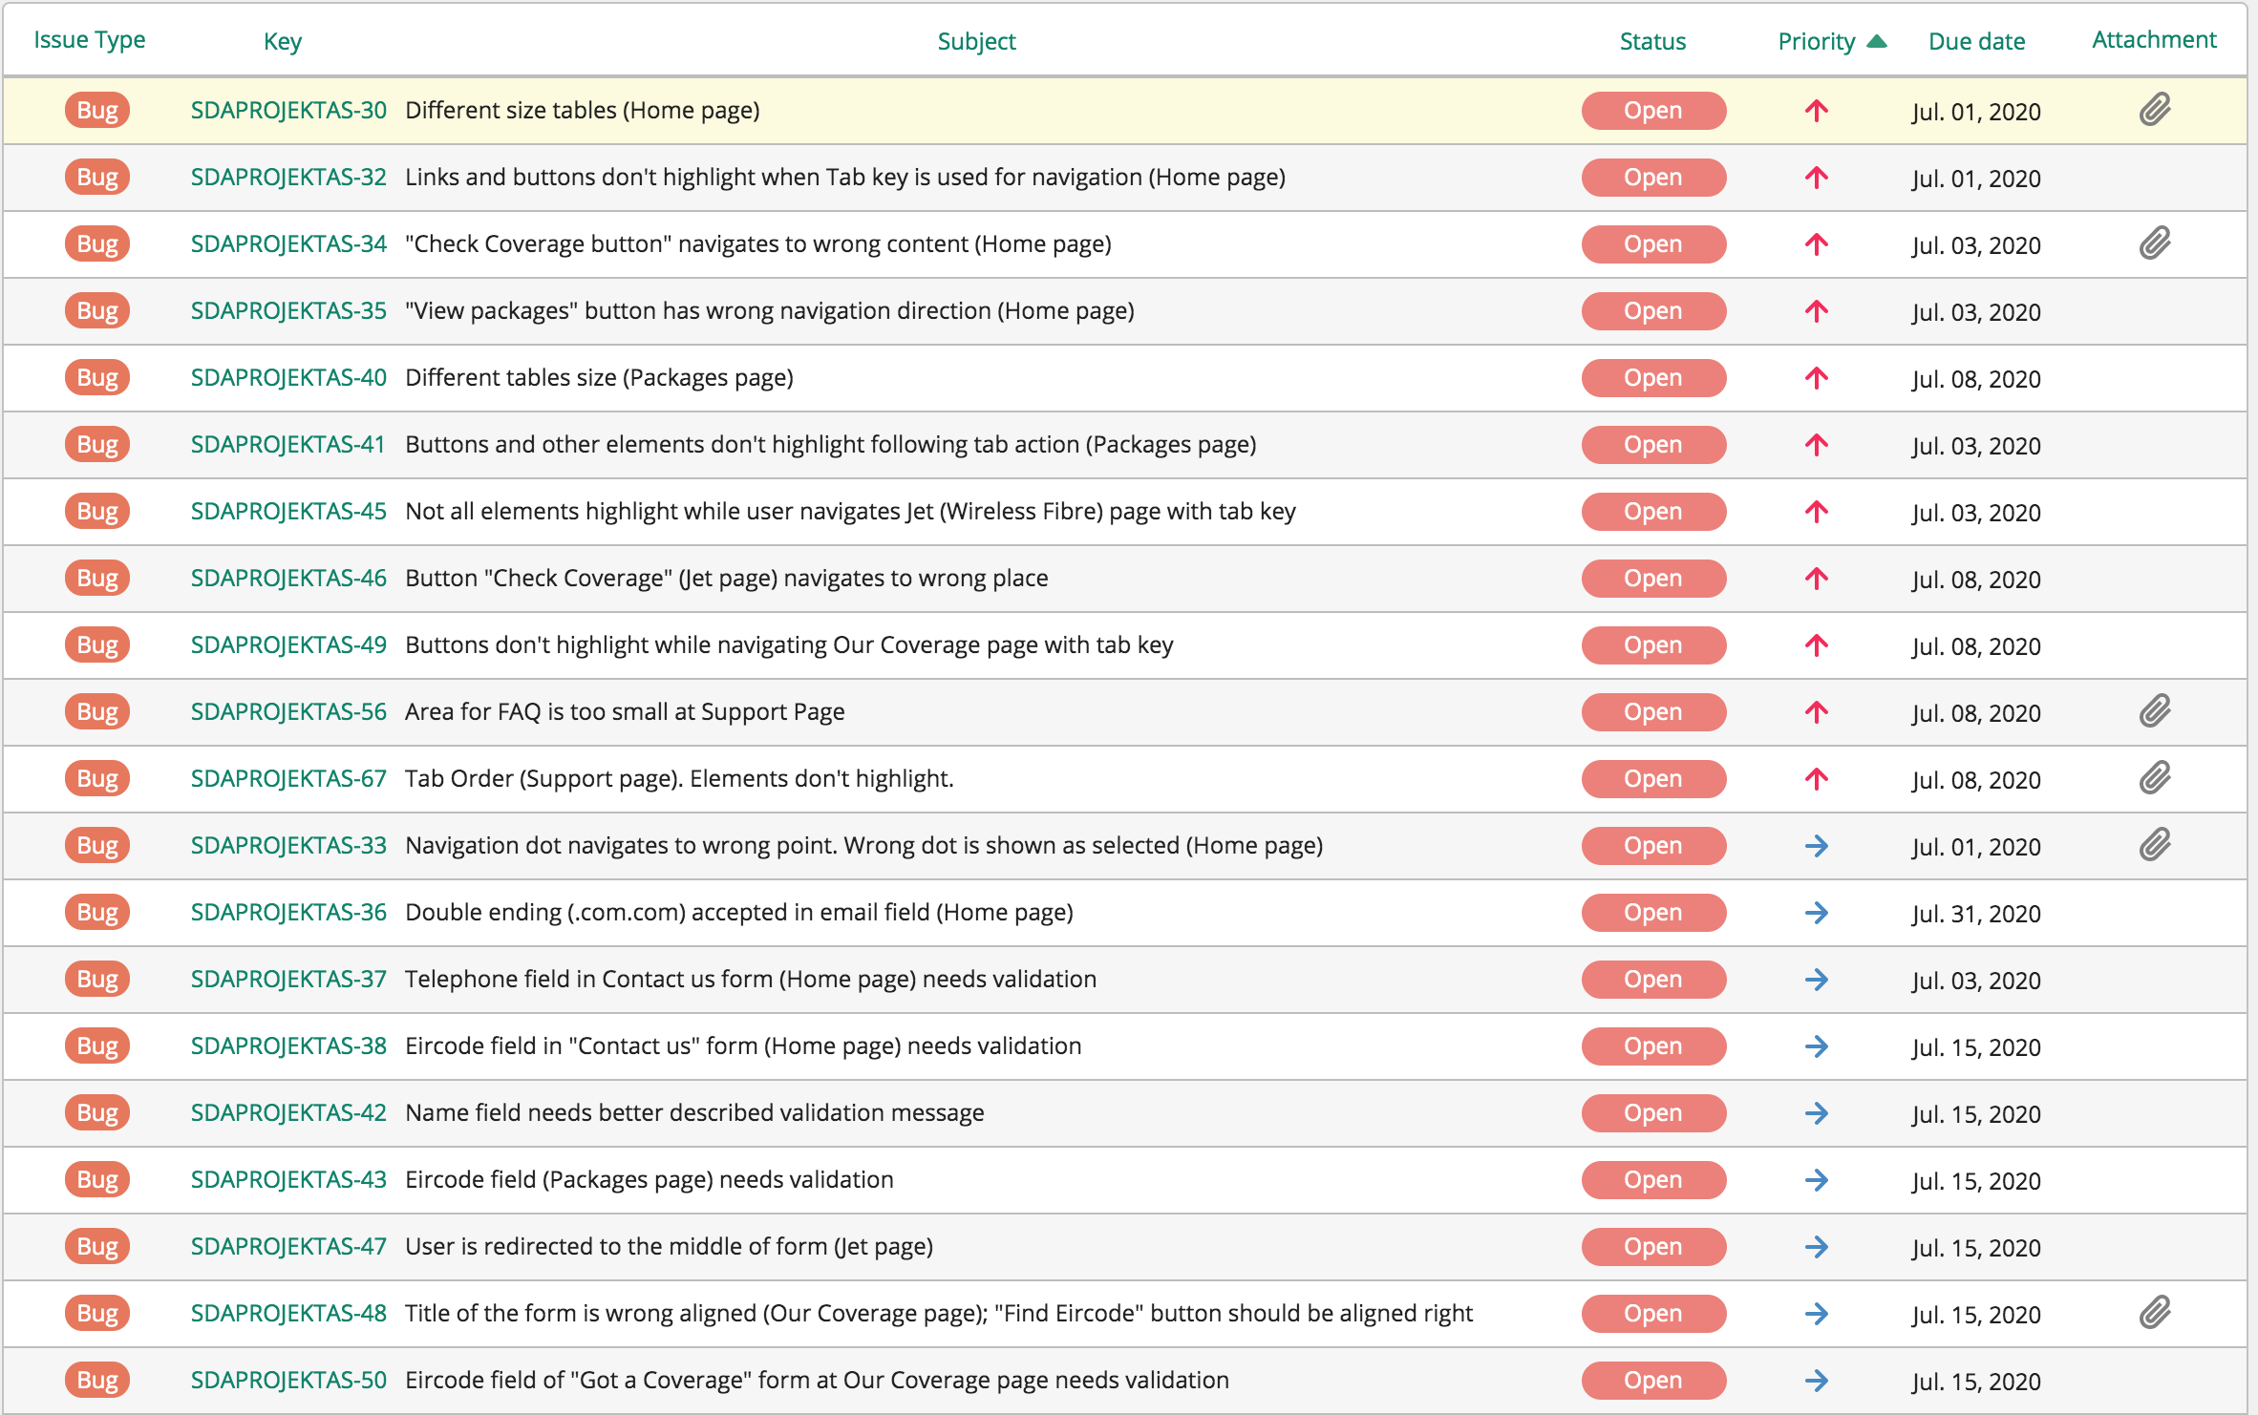

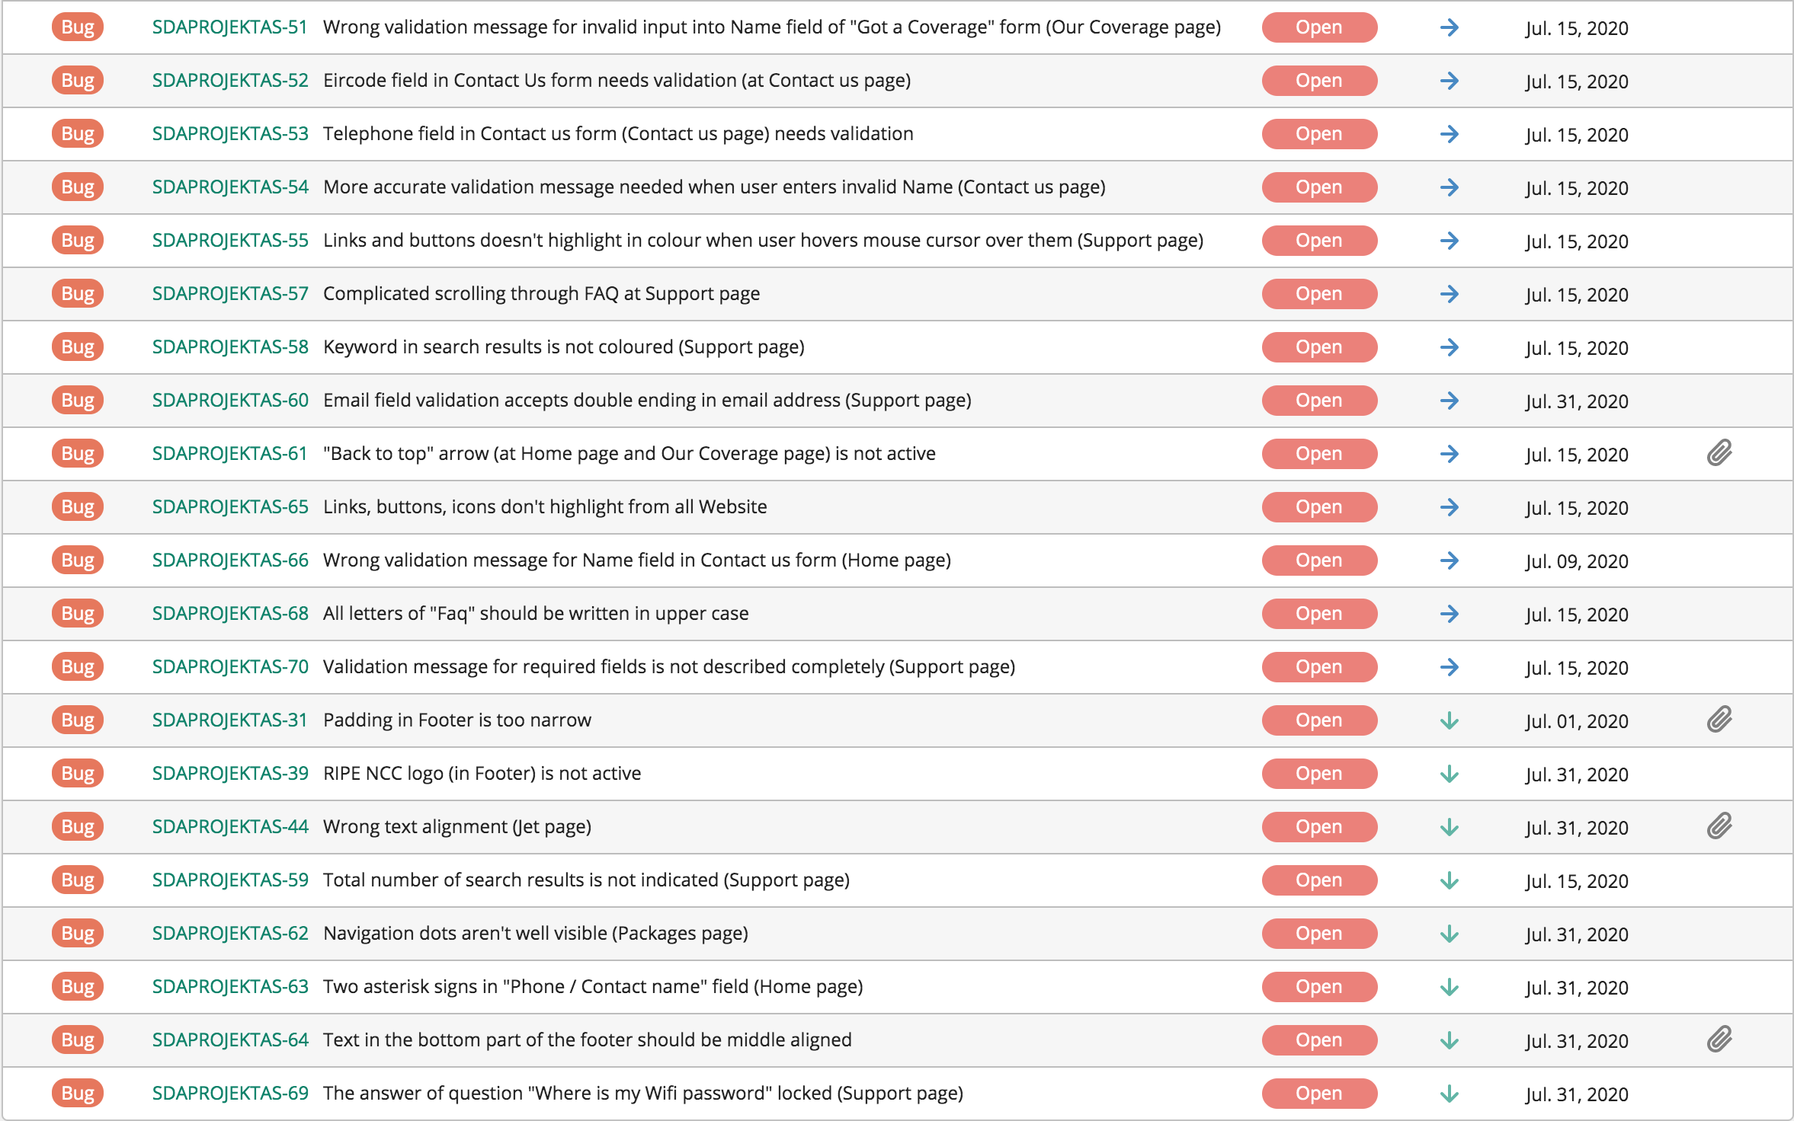

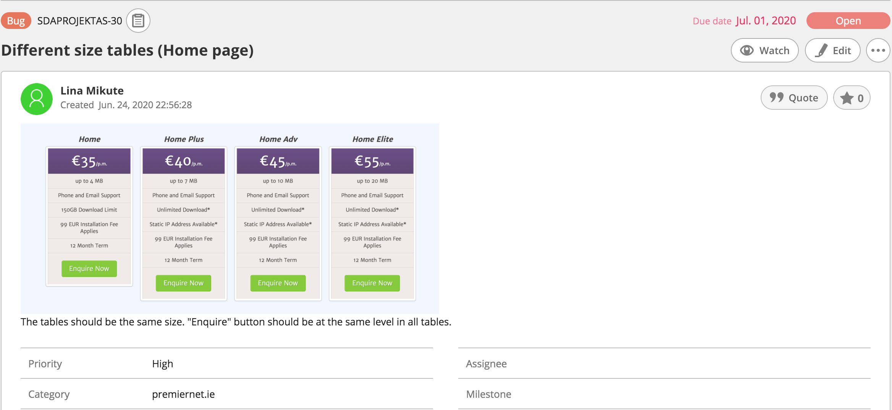

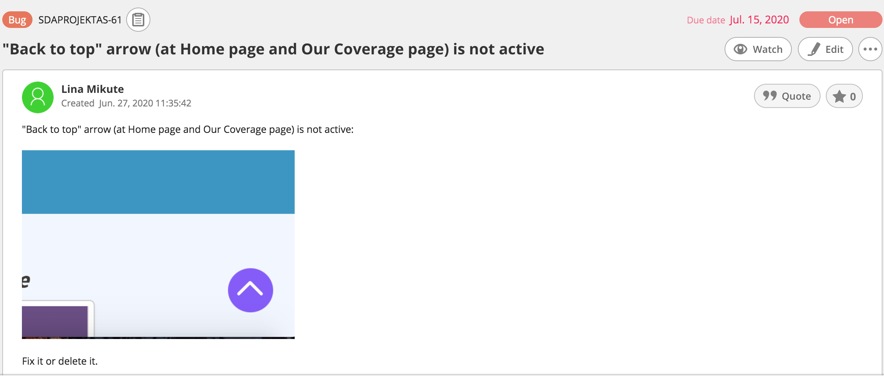

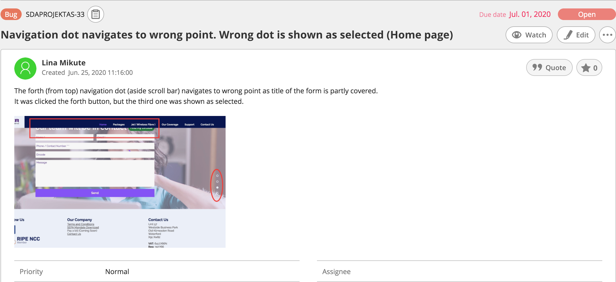

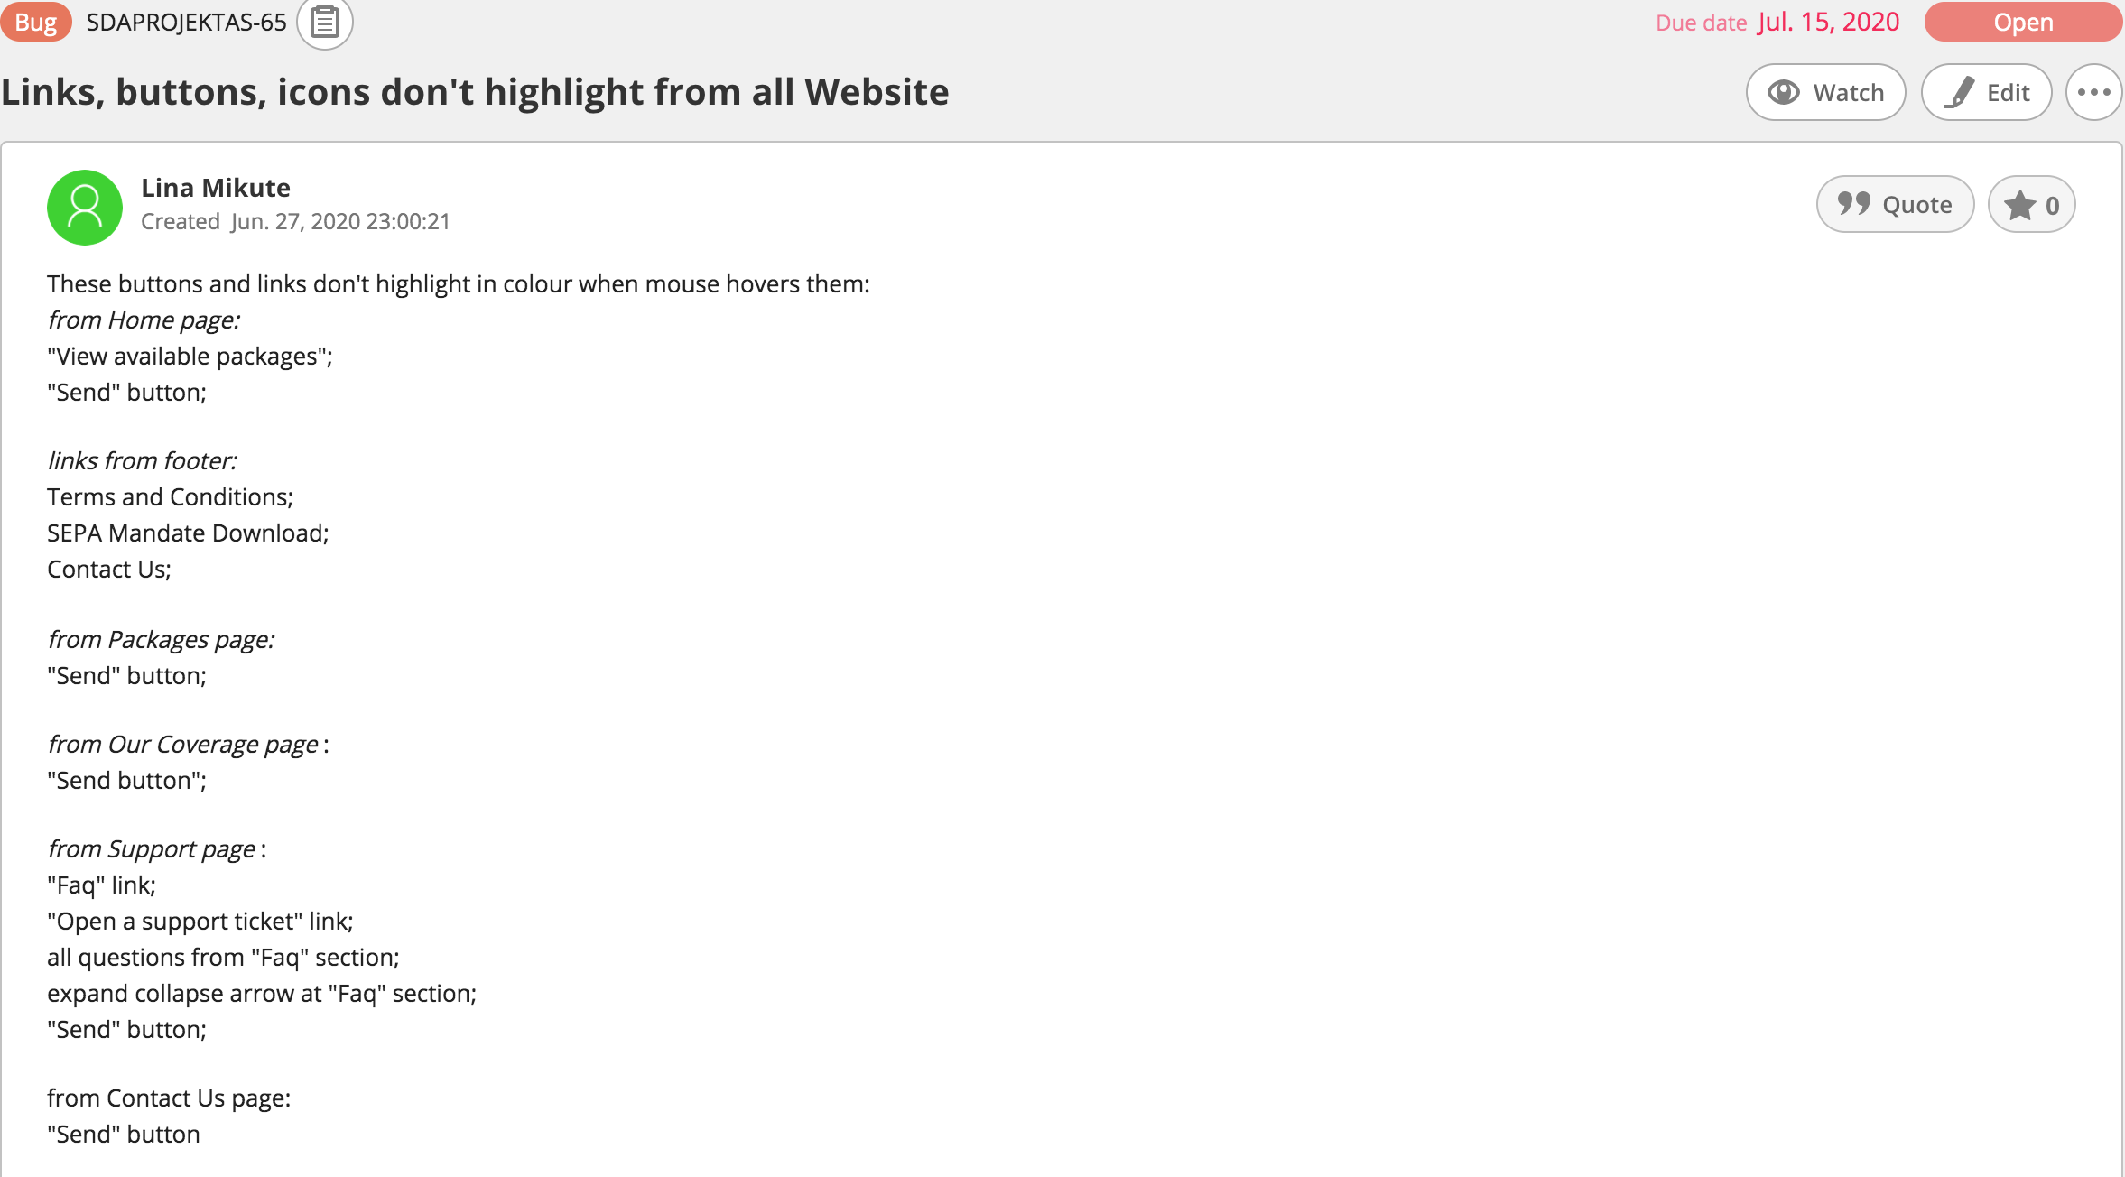

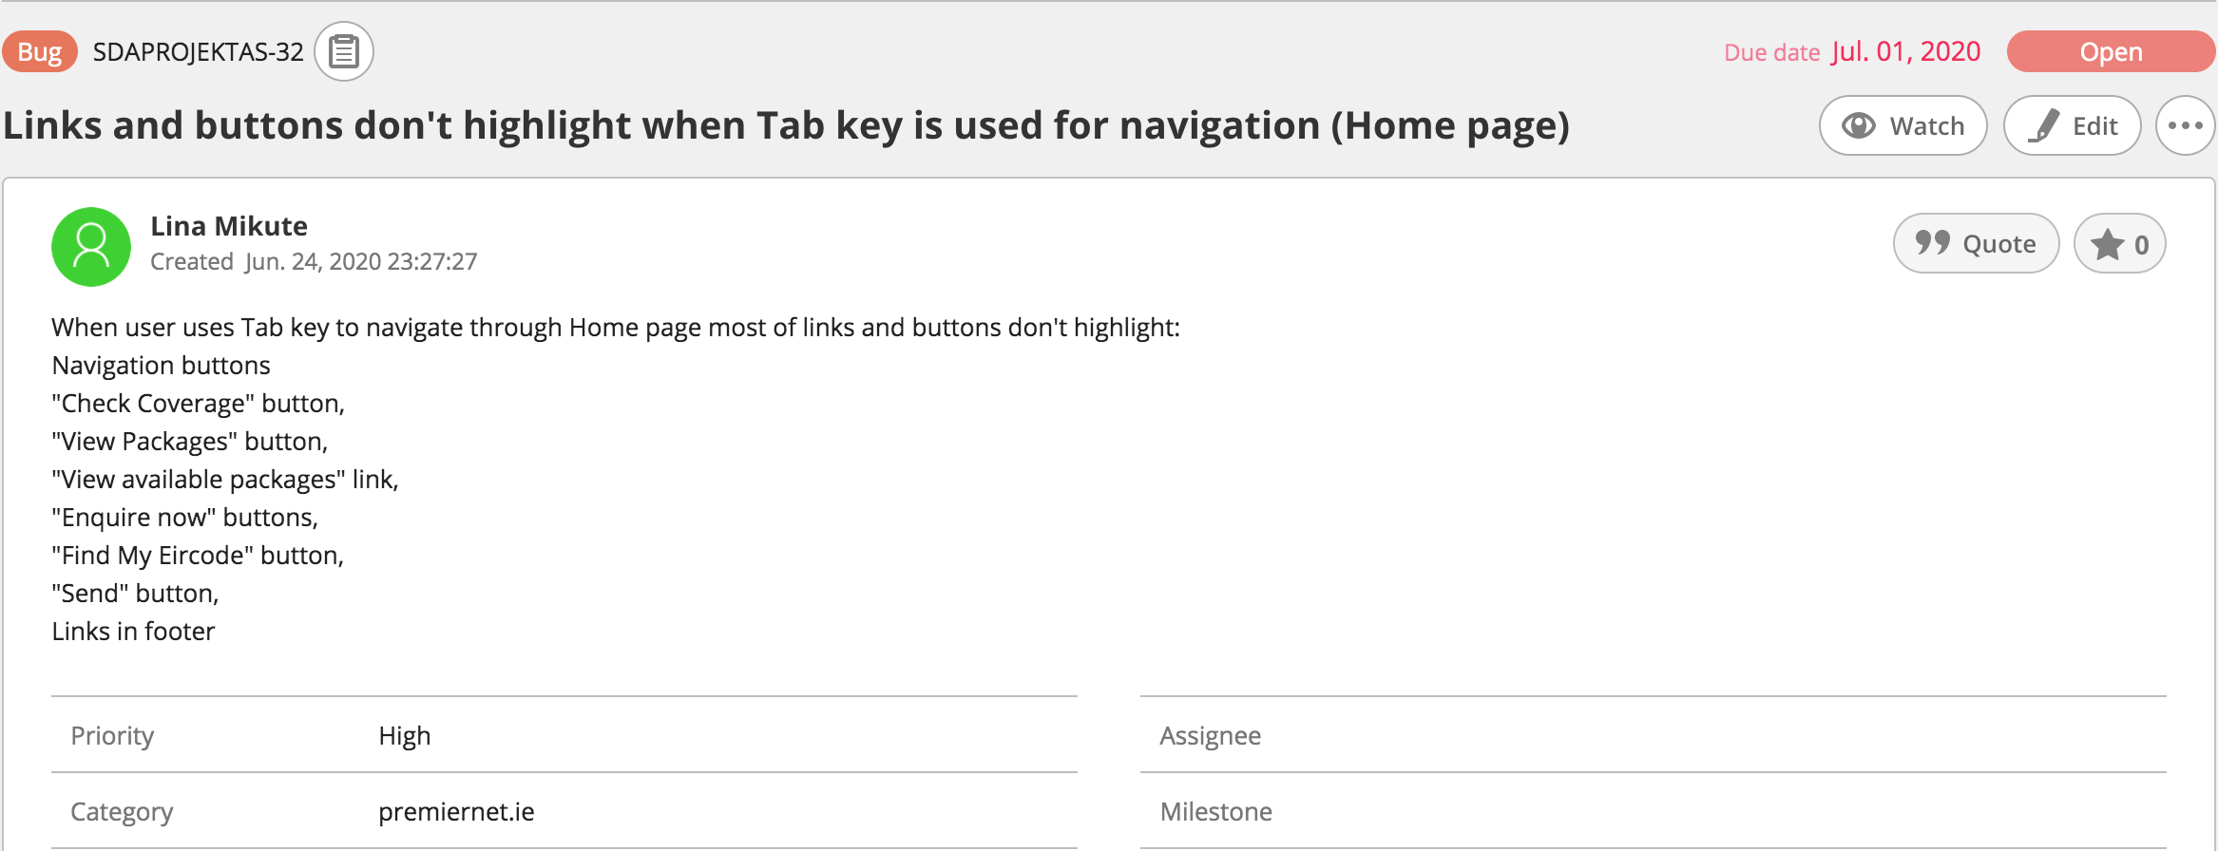

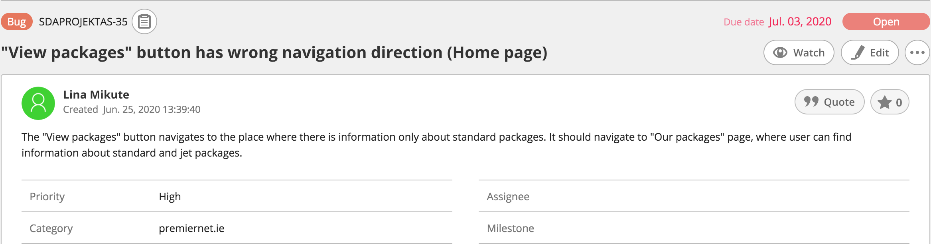

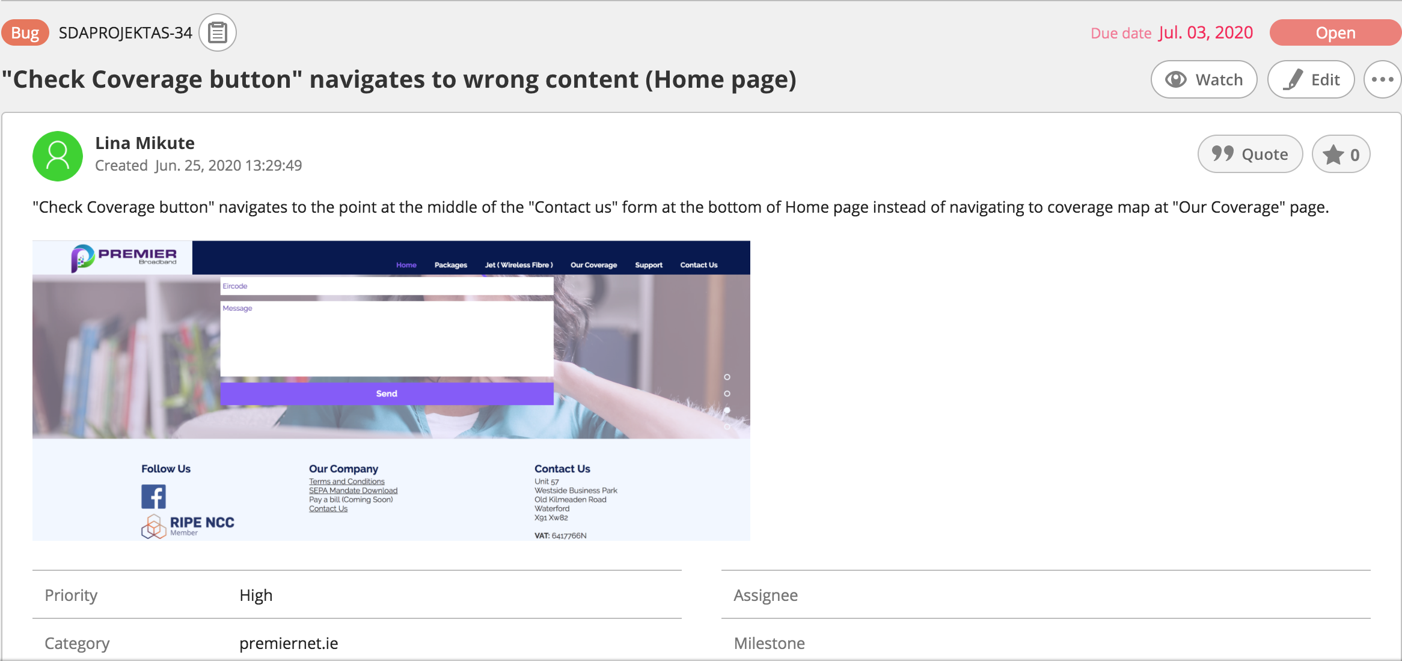

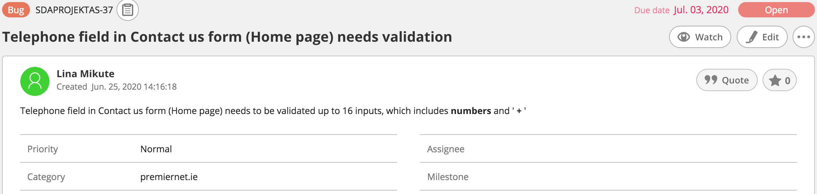

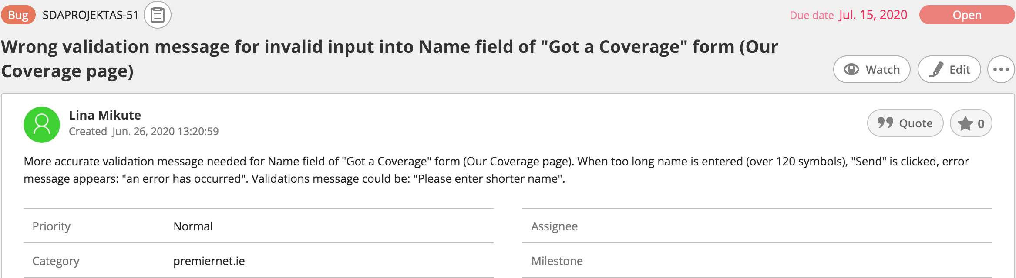

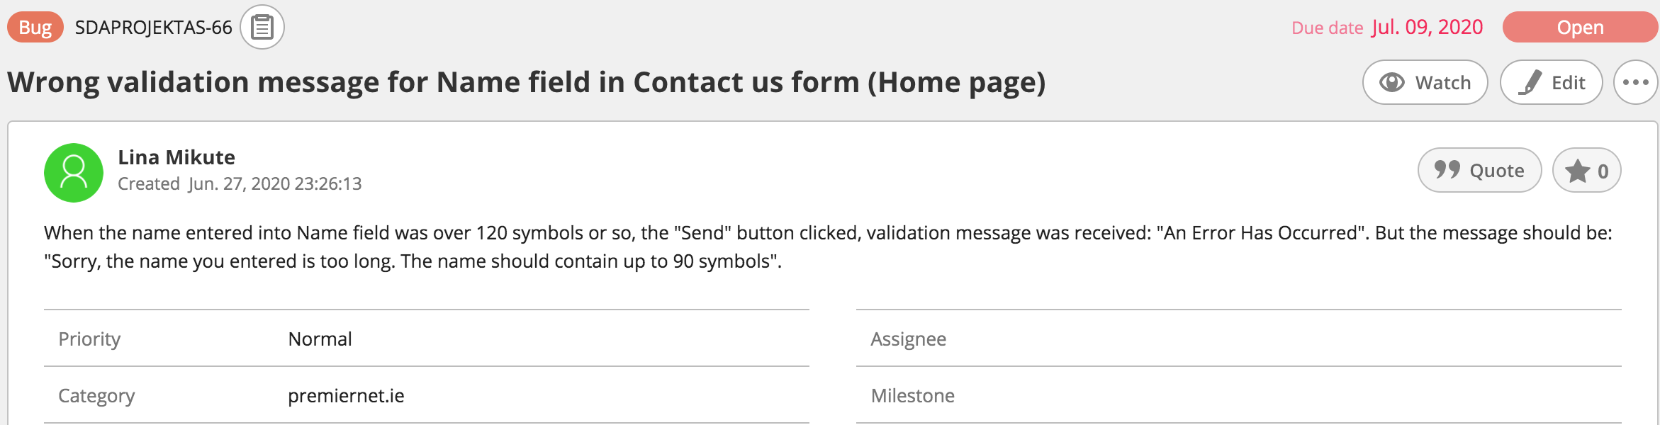

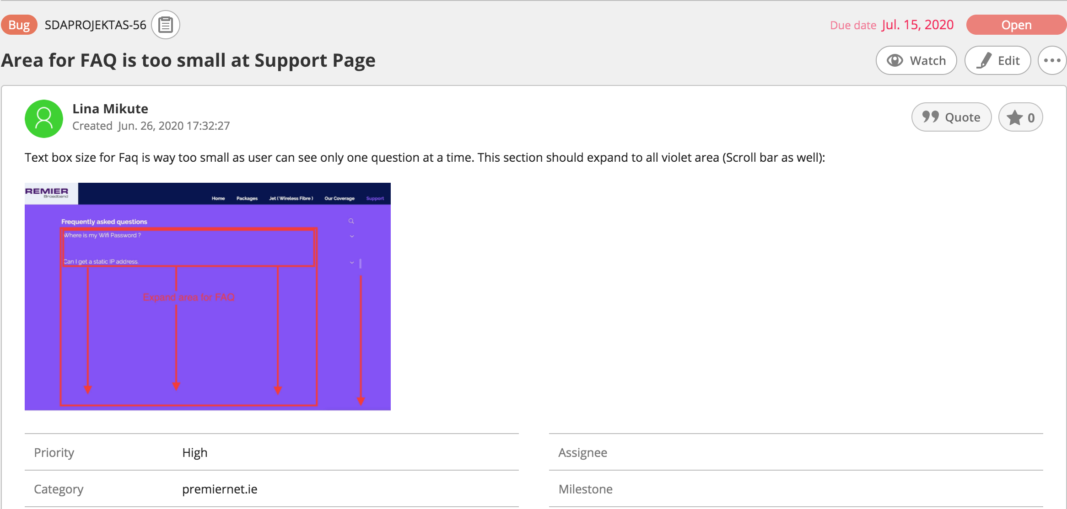

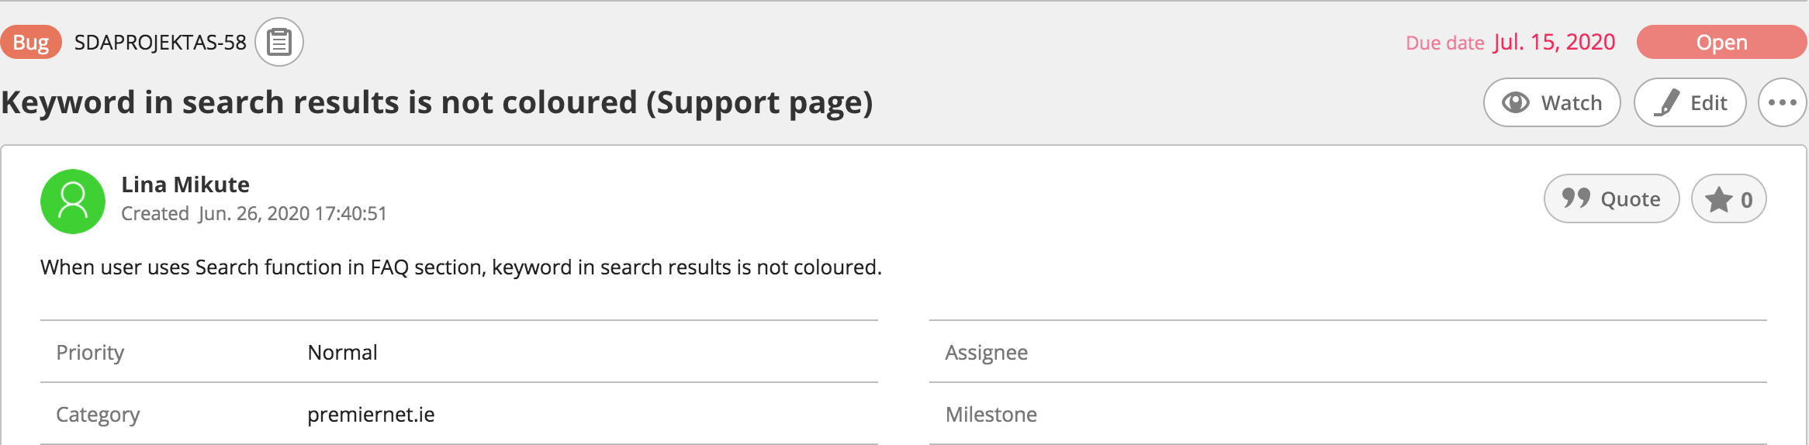

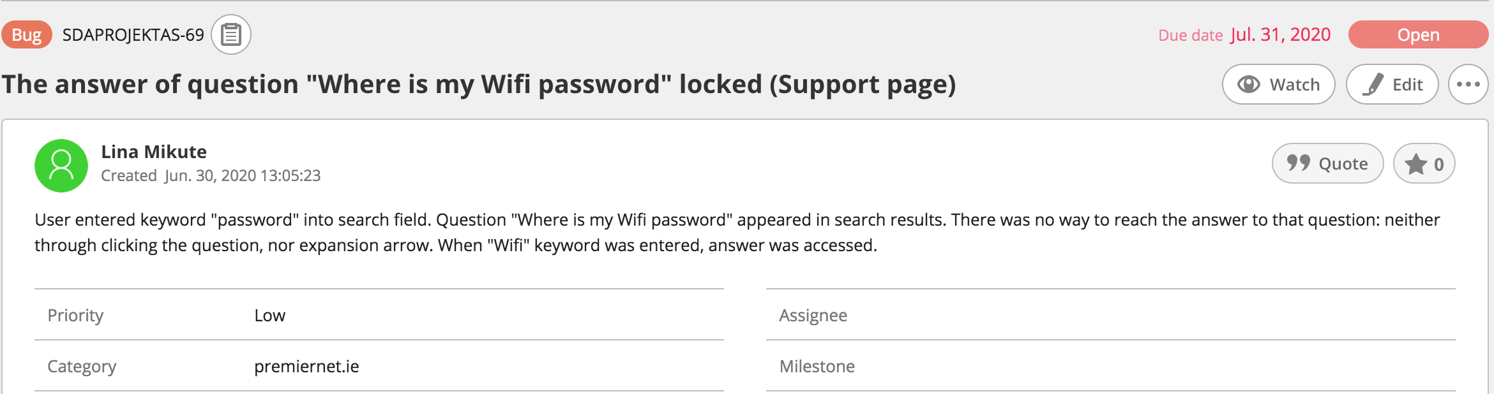

# Improvements

1. Website has quite a few elements (buttons, control elements) that are not necessary. In addition, they are not functioning well, therefore they might cause troubles in navigation through website.

Buttons “Check Coverage” and “View Packages” (below the heading of Home page) could be removed. Button “Check Coverage” leads to wrong content (“Contact Us” form at the bottom of the same Home page), while there is separate “Our Coverage” page. Button “View Packages” leads to content which contains just part of information about packages, and it is just a little bit below of the button itself. Right below the button there is a link to Packages Page (with all Packages described).

Similarly, buttons “Check Coverage” and “View Packages” (Jet (Wireless Fibre) page) could be deleted. The Button “Check Coverage” misleads the user to “Contact Us” form in Home page. The button “View packages” leads to the content which is provided below the button. Why does user needs to click the button if he can just scroll a little bit down the page?

Also “Back to top” arrows that are in bottom right corners of “Home” and “Our Coverage” pages should be deleted. There is no need of them, they are only in two pages of six, and finally they are not even functioning.

2. Text of whole website is written in Raleway font. This font itself is not very even: letters are in higher level than numbers. I would suggest to change font (might be Helvetica or Arial) used in Footer as text looks disorderly especially in “Contact Us” column where is mix of letters and numbers.

3. There is a search function in “Support” page Frequently asked questions section. It would be useful if search would be functioning in whole website instead of one section.

1. Test Design Techniques

First of all, experience based test design technique – exploratory testing was used for website testing. It was needed to test final product that was working website without knowing any requirements. It was not possible to compare actual product with requirements given.

Secondly, after exploratory testing, when product was more known, black box testing was used to do checklists and test cases. Functional and non-functional testing was done.

1. Reflection

Making a scheme for website was not difficult, but quite useful step for testing. It helped to understand website structure and where user is navigated when he presses certain button and link.

The difficult part was to test UI of website. It was not easy to name certain elements. Also, not knowing requirements made me in trouble when I had to judge style, design elements if they were ok or had to be corrected.

Finally, I had hard time finding words for bugs description. As I feel lack of IT language knowledge.

Good thing is I feel my skills for testing websites are improved after completion of Final project.